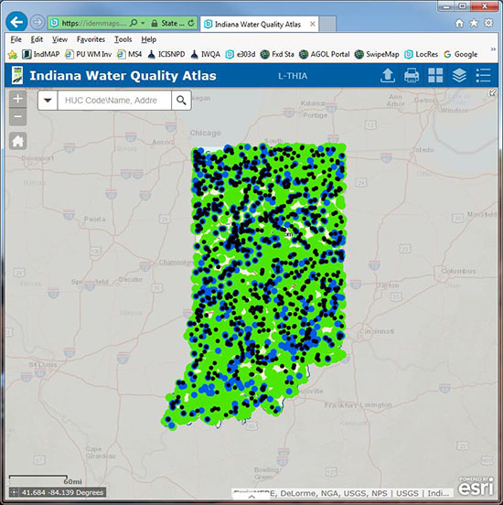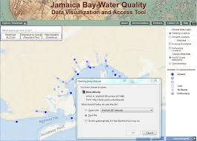

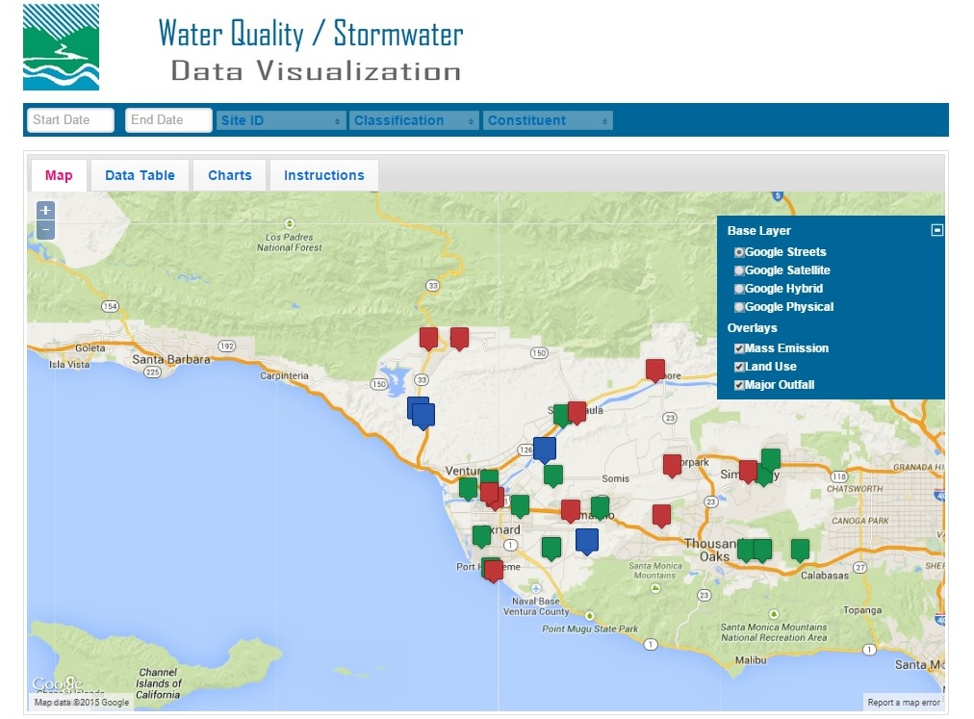

While commonly believed to be a fundamental human right, access to clean water has become a serious health concern in the United States. Water quality, which is not only a concern for residents of Flint, Michigan, could become a nationwide epidemic as droughts and containments threaten to overwhelm our already strained water supply. In doing our part to solve this issue, our project strives to increase awareness of water quality issues by creating an easy-to-use visualization tool of USGS water quality data. Our water quality dashboard will allow users to not only assess the drinkability of their water, but also develop an understanding of common chemicals found across their water basin and country. 